April 13, 2022
Your File
23053
Our File
1323916
Registration Number
TMA709,385
MICHAEL A. CARLI
(MILLER THOMSON LLP)
100 New Park Place,
Suite 700
Vaughan,
ONTARIO L4K 0H9
Attention: Michael A. Carli

RE: | Trademark: | WET BASEMENT?
 | Applicant: | ROMANELLI CONSTRUCTION COMPANY LTD.

Receipt of the correspondence dated October 30, 2021 is acknowledged.
This examiner's report concerns the above identified registration. A proper response must be received by this office by October 13, 2022. All correspondence respecting this registration must indicate the name of the registered owner and either the registration number or the number of the application that resulted in the registration.
The Office has received a request from MICHAEL A. CARLI (RIGOBON, CARLI) to group the services of this registration according to the classes of the Nice Classification.
However, in view of section 25 of the Trademark Regulations, Nice Classification requests submitted by anyone other than the registered owner (or their trademark agent if one is appointed) cannot be processed.
The registered owner’s attention is directed to the Practice Notice on Temporary Appointment of Agent or Associate Agent for One Communication dated 17 June 2019, published on the CIPO website, should they wish to temporarily appoint a trademark agent who resides in Canada for the purposes of Nice Classification.

Yours truly,
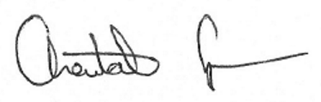
Chantal Cumpson
Examination Section
819-639-2244
fax: 819-953-2476

C.C. MICHAEL A. CARLI
(RIGOBON, CARLI)
SUITE 401
3700 STEELES AVE. W.
WOODBRIDGE
ON
L4L8K8

